RDSS 2.1 Illustrated Glossary
Card Summary Screen 1
Totebrowser Screen 4
Entries Screen 6
Tandems Screen 10
Field Screens with Selected Pacelines 11
Analysis/Original Screen 11
Analysis/Adjusted Screen 15
Analysis/Velocity-PoH Screen 17
Analysis/Velocity-PoR Screen 19
Analysis/Energy Screen 20
Analysis/PMTR/TPR Screen 21
Analysis/Segments Screen 22
Analysis/Primary Screen 23
Analysis/BL/BL Screen 25
Analysis/Rx Screen 28
Single Entry Screens 32
Analysis/Original 32
Tandems 41
Analysis/Adjusted 42
Analysis/Velocity-PoH 43
Analysis/Velocity-PoR 44
Analysis/Energy 45
Analysis/PMTR/TPR 46
Analysis/Primary 47
Analysis/Trip 50
Configure Screen 51
Paceline Tools Screen 51

mick
5/29/17

Card Summary Screen

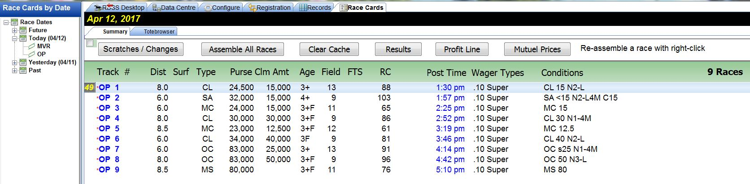

This is the “threshold” screen after cards have been selected, downloaded and converted for use by RDSS using the Data Centre screen. In addition to the functionality provided by the buttons across the top ribbon described below, basic information is displayed about each race’s distance, surface, type, purse, claiming price (if applicable), age, field size, number of first time starters (if any), race class, post time, wager types available, and conditions in an abbreviated format.

Scratches/Changes – provides a link to the Equibase “Late Changes” website for the track.

Assemble All Races – performs necessary preparatory steps for program use for each race on the card.

Clear Cache – reverses the “Assemble All Races” process.

Results – retrieves results charts for completed races.

Profit Line – connects RDSS 2.1 to TwinSpires’ “ProfitLine” tool; requires a TwinSpires account and login. (When activated, a small red dot will appear to the left of each race on the Summary screen.)

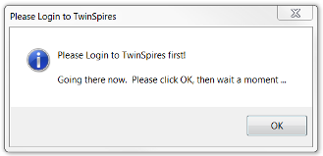

ProfitLine projects the top five finishers and is based on factors such as BRIS Speed, BRIS Class, BRIS Pace, form, weight, distance, pedigree, trainer, jockey, and recency. It is used by RDSS 2.1 as a component of the “Rx3” computation, described below on the Rx Screen.

Mutuel Prices – provides a link to the TwinSpires’ “Wager Now” screen, which also requires a TwinSpires account and login.

The Summary screen provides additional functionality with column sorting and surface/distance changes. Activate column sorting by checking the box under the Summary tab.

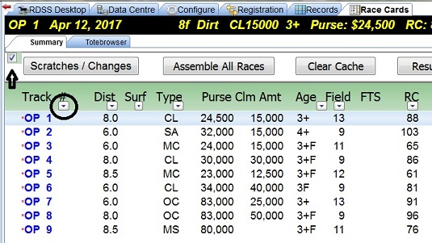

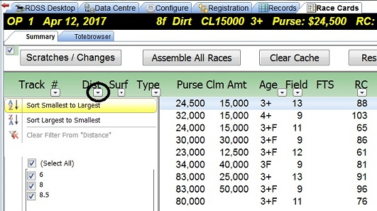

To change the surface and distance of a race, e.g. when a race is washed off the turf, right-click on the race’s distance. This changes values throughout the RDSS screens.

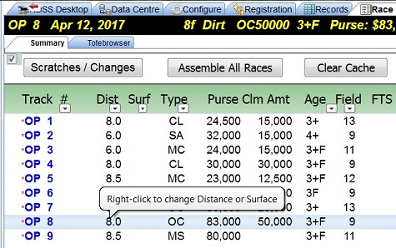

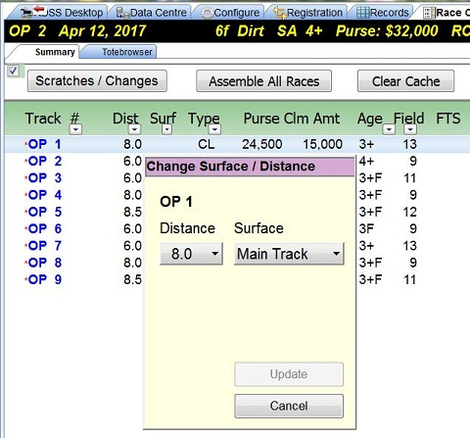

Totebrowser Screen

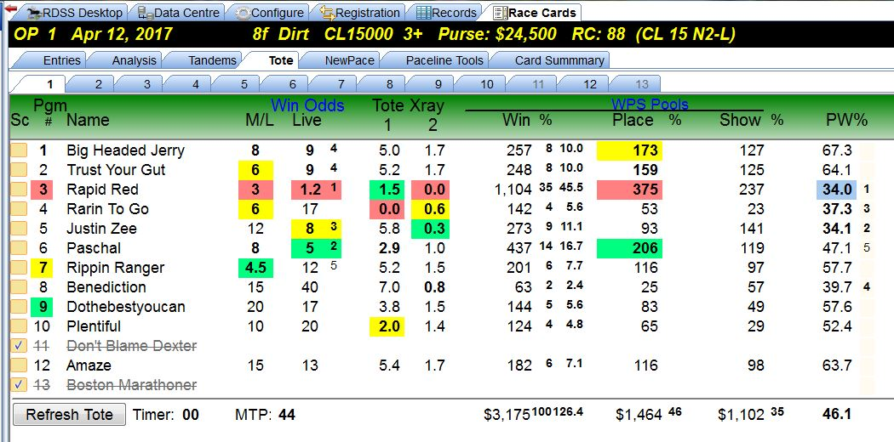

The primary purpose of this screen is to display “Live” win odds after Brisnet’s SuperTote has been started from the RDSS Desktop. SuperTote requires a Brisnet account and login. The following information is also presented.

Sc – a checked box indicates the horse has been scratched.

Pgm # - horse’s program or saddle cloth number. If colored, the horse is one of the top 3 in Class Rating (described on the “Entries” screen).

Name – horse’s name.

Win Odds
- M/L – Morning Line odds.
- Live – Live “tote” odds, if available.
Tote Xray
- 1 – a measure of relationships among the Win, Place and Show pools, expressed in the “Perceptor” format, i.e. percentage deviation from the best with the best expressed as “0.0”.
- 2 – the ratio of Place pool money bet on the horse to Win pool money bet on the horse, expressed in Perceptor format.
WPS Pools
- Win % - amount bet on the horse in the Win pool and its percentage of the total pool. The Win pool total is at the foot of the column.
- Place % - amount bet on the horse in the Place pool with the Place pool total at the foot of the column. The small superscript number to the right is the ratio of the total Place pool to the total Win pool.
- Show % - amount bet on the horse in the Show pool with the Show pool total at the foot of the column. The small superscript number to the right is the ratio of the total Show pool to the total Win pool.

PW% - “Place to Win” Percentage, a ratio of the money in the Place pool bet on the horse divided by the money in the Win pool bet on the horse. (It is derived from the same computation as Tote Xray 2 but expressed as a percentage.)

Entries Screen

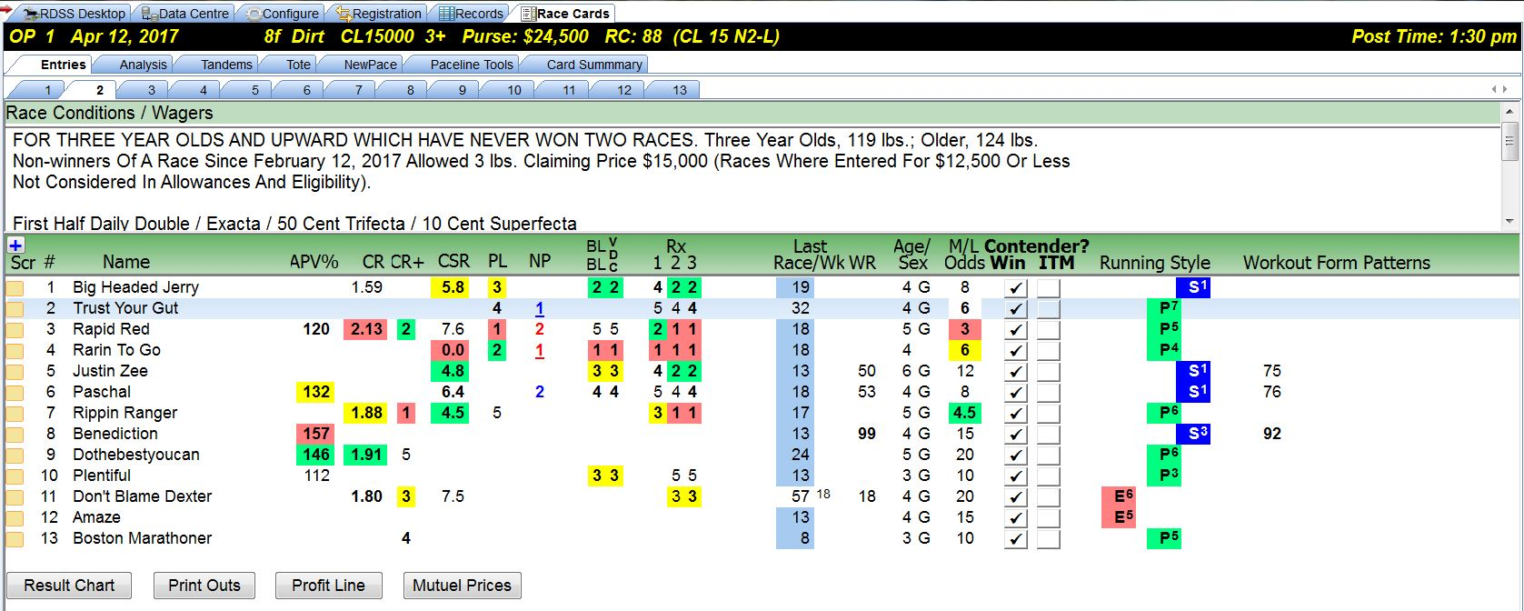

This screen displays basic information such as race conditions, names of horses, saddle-cloth/program numbers, scratches, age, sex, and morning line odds. The following are additional data columns.
APV% – Average Purse Value. The percentage of the horse’s average competitive (i.e. in the money “IM”) purse value as compared to today’s purse value. Values over 100% mean the horse has raced competitively for purses higher than today’s while under 100% means the purses were less. It is a measure of “Class.”
CR – Class Rating. A rating comprised of Average Purse Value, Earnings per Start and IM percentage of the horse’s six most recent starts. It is an overall measure of the horse’s competitiveness and consistency, relative to today’s class level as expressed by purse value.
Note: CR is based on earnings and consistency and not on speed or velocity or deceleration. Consequently, when a horse ranks well on both class and the non-correlated variables of velocity/energy, you have confirmation from two different and unrelated sources of the horse’s potential, assuming good form. http://paceandcap.com/forums/showthread.php?t=10405&page=2
CR+ - Class Rating Plus. An enhanced measure of class that uses the older CR with a weighted ranking of the horse’s final odds from its last four races. Final odds are often an excellent measure of class.
CSR – Composite Speed Rating. A weighting of the RDSS Adjusted Speed Rating from the last 4 usable lines, regardless of distance, surface, race conditions or finish. The weighting is as follows: 100% of the last line SR + 62% of the average of the last 2 lines SR + 38% of the average of the last 3 lines SR + 24% of the average of the last 4 lines SR. Thus the last line SR has a major weighting in the CSR, with the weighting declining for older lines.
PL – The ProfitLine ranking, described previously on the Card Summary Screen.
NP - Early/Late Plus. Indicates the top two Early and top two Late horses, using a refined pace method.
BL/BL – Bottom Line Betting Line rank. BL/BL will be described in detail on the BL/BL screen below.
VDC – Velocity relative to Deceleration ranking. VDC indicates how well a horse did at overcoming the pace of the race. VDC will be described on the Segments screen.
Rx1, Rx2, Rx3 – Rx is a composite line score factor comprised of weighted input from VDC, CSR, CR+, EL+, and an additional component, as follows:
- Rx1 – uses Morning Line rank
- Rx2 – uses additional weighting for CR+
- Rx3 – uses ProfitLine (PL) from Twinspires
http://paceandcap.com/forums/showthread.php?t=10574

Last Race/Wk – Days since last race and since last work.

WR –Work Rank. A computation based on the average percentile of a horse's workout rank for all workouts in a day (when at least 5 workouts recorded that day), plus furlongs worked and raced - over the past 30 days. It’s a measure of the horse’s fitness.
Contender? Win / ITM – Indicates whether the handicapper believes the horse is a contender to Win, to finish in the money, or is a non-contender.
Running Style – Indicates the ‘visual’ Sartin/Bradshaw/Brohamer running styles and Quirin Speed Points. While the definitions of running styles may differ with the individual, the following is from "Jim Bradshaw's 5 Step Approach to learning the Matchup" in the Hat Check forum.
When handicapping a horse race, determine the running styles of each individual horse. These styles help to answer the important question, how is this race going to run? A race is a 'herd on the move' and all horses are characterized by one of the following four (4) designations; Early Horse, Early Presser, Presser and Sustained Presser.
There are three main running styles that figure in a horse race. In most instances these styles are determined by the position where the horse likes to run, rather than how fast the horse runs.
1. EARLY - Is a runner whose very best races are on or near the lead, or within a length while attempting to get the lead. A winning effort is accomplished only in this manner, and is usually a wire to wire effort.
2. PRESSER - Is a tactical runner that lays just off the pace, comes on in the second and third fractions. These horses may force the early horses to exert their energy to maintain the lead. These horse are usually up close to the early runners, but are not effected by the early pace.
A. Early Presser is the horse that takes dead aim at the leader but prefers someone else lead. They sit next to the leader and hope that at some point in the race the front runner tires so that they may go by. These horses do not lead and if they get the lead, will not win. Early pressers may put pressure on the early horse and, most likely, will never go by. In a herd environment, these horses are observed positioning themselves as close to the early horse or the ‘boss’ but never brave enough to lead or become ‘boss’.
B. Sustained Pressers are the most exciting of the running styles. The Sustained Presser likes to stay way behind and hopes that there is a fast pace and all the Early, Early Pressers and Pressers have expended all their energy and tire so that their stretch run gets them to the front in time. In a herd, these horses will be observed lagging behind and are fair game to whatever is chasing the herd. Sustained Pressers are the least reliable of the running styles and rarely win races.
3. LATE (Sustained) - Is a runner that comes on late in the race, often after the early runners, and pressers have exerted all their energy. They are habitually in the back of the pack, and win by catching the leaders in the third fraction (3F.)

Workout Form Patterns – Abbreviations to document how the horse has been working, as follows:
- FPD - Furlongs Per Day. When there are 2 or more workouts since the last race, and within the past 30 days: count the furlongs worked including the distance of today's race and divide by days since the last race. 1 furlong per day = FPD, less is -FPD, more is +FPD. We're trying to get a coarse idea of how much public work the horse has been doing to return to racing. You can only put so much value in this info - this does not tell us how much private work the horse has done, the frequency, the speed, the pressure during (e.g. working in company, working inside/outside other horses, etc), the distance, etc. Consult other Workout Patterns for some of these.
- 5f / 6f - 5 or 6 Furlong Workout. The last workout within 9 days of today's race was either 5 or 6 furlongs, an important endurance distance associated with at least a certain degree of fitness, especially if combined with a good Speed Rating and coming at the end of an evenly spaced series of works (see HWL group). If the last work was within 6 days, will be indicated with a plus, e.g. +5f or +6f.
- SRW - a Short Recent Work between 2f - 4f within 3 to 5 days of today's race
- SW - Super Workout. Depending on distance and recency, a designation for the LAST workout within the past 14 days, run faster than a certain time for each distance.
- GW - Gate Workout. Within the past 8 days, a workout from the Gate. Extra credit for more recent gate workouts (* ! + modifiers)
- HWL1 - Heavy Workload 1. 3 or more workouts within the last 21 days. +HWL1 for 4 works in 20 days or 3 works in 16 days. -HWL1 for 3 works in 21 days
- SAR - Heavy Workload 2. Between 4 and 7 workouts since the last race at *regularly* spaced intervals. Extra credit for more workouts.
- SCW - Special Condition Workouts. Comparing workout immediately prior to the last race within 60 days to workout immediately following that last race - the latter workout is faster and may indicate that the last race did not adversely affect the horse. Or, comparing workouts immediately preceding and following the last 2 races with an out of the money finish, the later workout should be faster, perhaps indicating that the previous 2 races also did not adversely affect the horse's condition and it may be ready to offer at least as good an effort today.
- PIW - Progressively Improving Workouts. Comparing the past 3 workouts within 75 days (preferably shorter), each next workout should be run at increasing average speed.
- TCW - Turf Course Work. For a horse's first Turf race, its last workout is on Turf.

Adjunct to Workout Patterns themselves are the Workout Rank and the Workout Speed Rating.

- WR - Work Rank. A computation based on the average percentile of a horse's workout rank for all workouts in a day (when at least 5 workouts recorded that day), plus furlongs worked and raced - over the past 30 days. A measure of its fitness.
- SR - Speed Rating. A rating of workout time, based on a parallel time chart equating times for different workout distances. Speed Ratings of 92+ may indicate the horse is extremely fit and sharp, especially if the workout distance is 5f or longer.
http://paceandcap.com/forums/showpost.php?p=97044&postcount=13

Tandems Screen

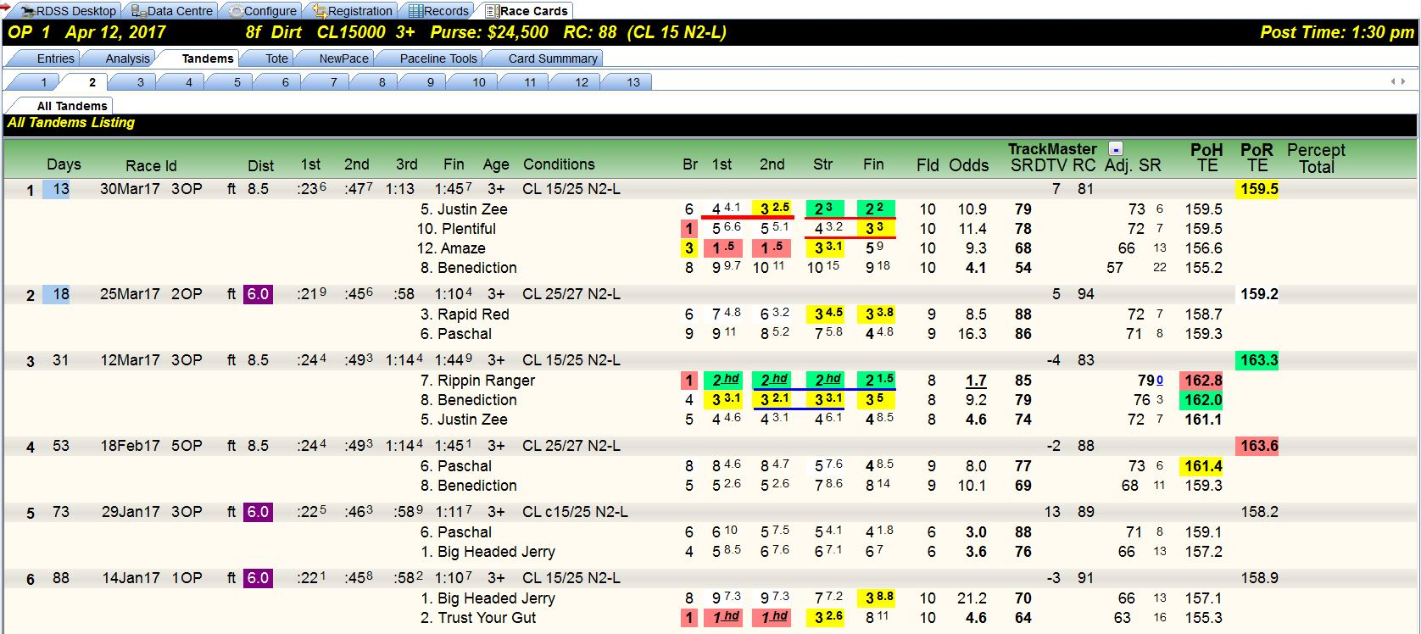

This screen displays prior races where two or more of today’s entrants have competed. Tandems are an element of Jim Bradshaw’s “Match Up” approach. All data is assembled from other screens, primarily the Analysis/Original with one column each from the Analysis/Velocity–PoH and Analysis/Velocity-PoR, and will be described on those screens.

Field Screens with Selected Pacelines

Analysis/Original Screen

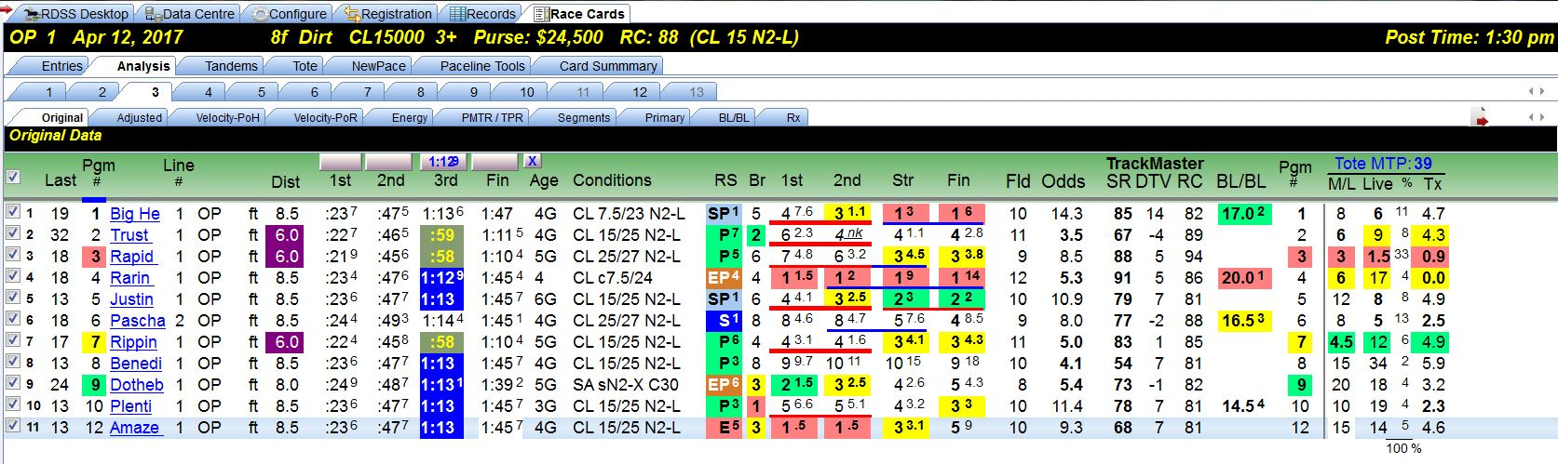

The “field” screens provide information about all horses in the race and their selected pacelines.
In addition to traditional past performance information, the Analysis/Original screen displays TrackMaster supplied data, BL/BL values and if enabled, live tote information. The fractional and final times are unadjusted.
Last – Days since last race and in superscript, days since last work. The same information appears on the ‘Entries’ screen as ‘Last Race/Wk.’
Pgm # – Horse’s program or saddle-cloth number, followed by horse’s name.
Line # – The paceline (or running line or race) selected for evaluation. Of the following 17 columns, 16 are taken directly from the horse’s Equibase past performances for the selected paceline. ‘RS’ designates the horse’s “Running Style” and in superscript, the horse’s Quirin Speed Points, which also appear on the ‘Entries’ screen.
TrackMaster Supplied Ratings
- SR – TrackMaster’s Speed Rating, from which Inter-Track Variants are extracted, used to adjust the running times in all Sartin download programs. It’s the horse’s final time in the selected paceline race adjusted by:
a) Daily Track Variant (how fast/slow that day's surface was);
b) Inter Track variant (how fast or slow each surface is relative to a universal norm); and
c) horse's speed rating (compared to the 'par' for that track/distance/surface).
- DTV – Daily Track Variant of the selected paceline race. (RDSS has a feature available on the ‘Config’ screen to ‘smooth out the extremes’ for very slow and very fast races, e.g. + - 15, so that the final times aren’t adjusted unreasonably.)
- RC – Race Class, a composite of the most recent final time Speed Ratings of all the horses in the selected paceline race. (It’s included for reasons of historical continuity as it was in some Sartin programs, but Dr. Sartin did not use it and Ted recommends that it be ignored except that is useful for rating Foreign Shippers, as this TimeForm International Rating can be used to compare foreign races’ relative Class Levels with all other horses, typically at the Breeders’ Cup!)
BL/BL – Bottom Line/Betting Line. Bottom Line refers to a Line ‘Score’ that is computed by adding the seven Primary factors with their specific weightings, later displayed on the “Primary” screen. The higher the score, the better. Betting Line refers to the ‘Odds’ line generated by RDSS from the Line Score, which is shown on the Analysis/BL/BL screen, but not on this screen.

Tote
- MTP – Minutes to Post
- M/L – Morning Line Odds on the horse.
- Live – Live tote odds on the horse.
- % – Horse’s odds of winning expressed as a percentage.
- Tx – Tote Xray. Measures relationships between the WPS pools. If Tx values and ranks align with win odds, there’s no extra info provided by Tx. If a horse’s Tx diverges from its BL win odds, the horse may be live in the opinion of the crowd yet somewhat hidden in the win odds.

Quote from Ted:
“One of the original uses of what became TX was to dutch or hedge between the top 3 TX ranks. If Win Odds are low (e.g. < 2-1) and match the TX rank, hedge a portion of the bet so that you break even or lose only a little (like insurance) if this favourite actually wins, and dutch the rest of your Win bet unit to make about the same desired profit on the next 2 ranked TX when the favourite loses. You can certainly do this using Win Odds only, but the idea was that the TX gives some extra info -an Xray beneath simple visible-to-the-public Win Odds alone. Since there is no handicapping involved, you can do it in bulk, and on quarter horses, standard breds, Arabians, UK, Australian, Far East racing...
For the record, I don't know whether those who use TX this way make money long term. When I use TX, it is often for races with young horses or First Timers, or foreigners - i.e. where my normal analysis fails. Or, where there is lots of chaos and the favourite is perhaps 3-1 or higher. If my handicapping analysis likes a horse, and the TX likes a horse and the Win Odds are generous - time to pay attention. It's another tool to be used selectively, where it has value.”
http://paceandcap.com/forums/showthread.php?t=6257

Additional Functionality

On most of the field Analysis screens, the values in certain columns can be sorted. To determine which columns, move the mouse pointer over the column header and if the pointer changes to a Select Link or “hand”, that column is sortable.
For example, on the Original screen, the following columns can be sorted: Pgm #, 1st Call Time, 2nd Call Time, Final Time, RS, and M/L Odds. The current “sort” column is identified by a blue underline at the top of the header. These screenshots illustrate sorting on Running Style:

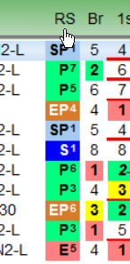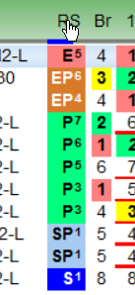

On the Original, Segments, BL/BL and Rx Analysis screens, a horse with 0.0 ratings at the first 2 calls of the Segments screen (i.e., energetically dominant through the 2nd Call) AND an Early Running Style designation (F, E or EP) is given a special markup to draw attention to a visually Early dominant horse among the energy-adjusted readouts. Space permitting, the markup is a red underline at the first 2 calls AND a right-pointing arrow and underline rank. (For testing in any race, simply find a double 0.0 rating on the Segments screen and if the horse is not designated Early, change its Running Style to F, E, or EP.)

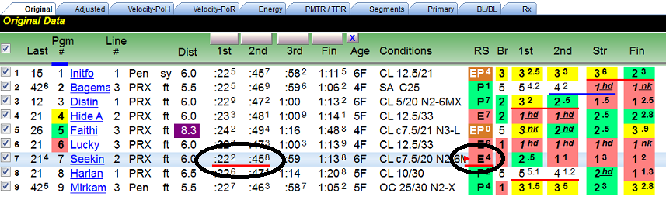

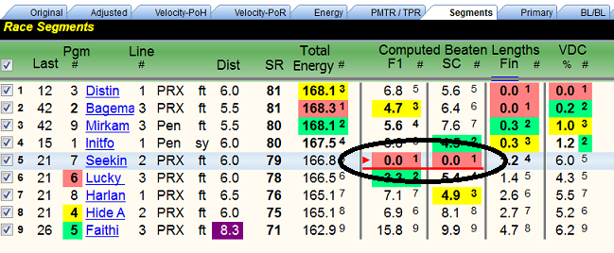

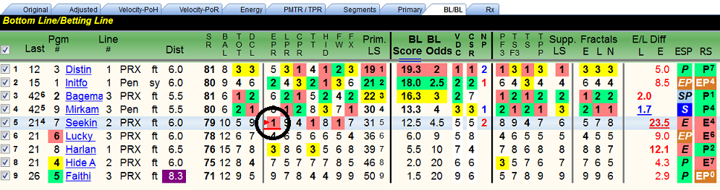
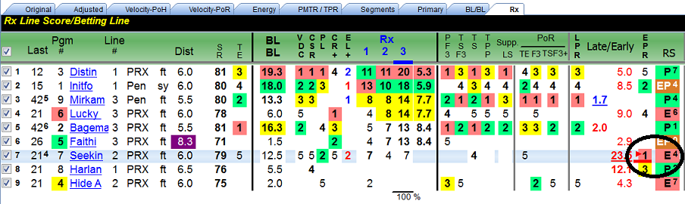

Analysis/Adjusted Screen

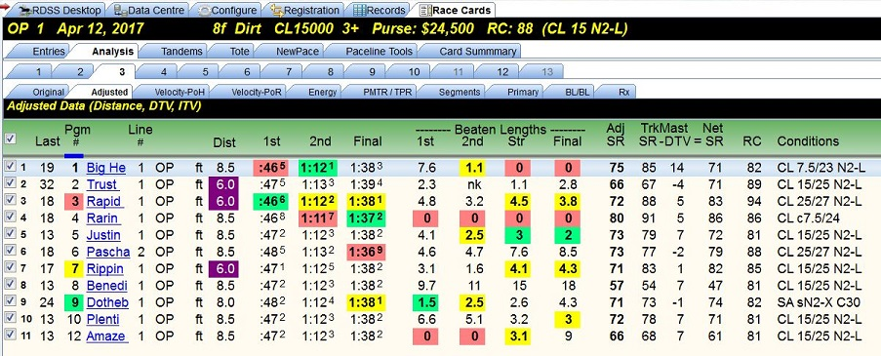

This screen displays each horse’s selected paceline with the fractional and final times adjusted by the TrackMaster’s DTV and ITV. If today’s race is a different distance and/or surface, those fractional and final times are also adjusted or “equalized” to make them consistent with today’s distance and surface. (Compare the fractional and final times with the unadjusted numbers from the “Original” screen.)
Note - With the tabbed screens under ‘Analysis’ to the right of the ‘Original’ screen, all factors and numbers are adjusted and equalized. The only raw, unadjusted data is on the Original and Tandem screens, the Workout Form Patterns data on the Entries screen and the Tandems, Workouts and Trip information on each horse’s PP screen. Beyond that, nothing is raw unless the user has changed the default settings on the ‘Configure’ screen, which is not recommended.
Also displayed on this screen is an ‘Adj SR’ and a TrackMaster ‘Net SR’ with calculation.
Adj SR – Adjusted Speed Rating, computed by RDSS using internal formulas and includes:
1. Final time component;
2. Distance adjustment to today's distance (if necessary);
3. TrackMaster's Daily Track Variant (DTV) adjustment (controlled on the Config screen); and
4. TrackMaster's Inter-Track Variant (ITV) adjustment
The Adjusted SR is not the same as the TrackMaster SR and it does not include adjustments for:
1. 'class' as determined by earnings or in-the-money consistency (i.e. elements of APV and CR);
2. race conditions or caliber of race (race class levels, non-winner conditions, etc);
3. 'track class' or relative level of purse structures or perceived abilities of horses who race at different race tracks or circuits; or
4. incremental race segment components (e.g. 'pace' time ratings, fractional ratings).

It is strictly based on adjusted final time, and as such will have a direct one-to-one rank relationship with Total or ‘True’ Speed (TS) which is the velocity equivalent of the Adjusted Speed Rating (i.e. the rankings of these two readouts would be identical).
http://paceandcap.com/forums/archive/index.php?t-8004.html
TrackMaster Net SR – “In Validator and Speculator, the TM SR shown is the Net SR, i.e. original TM SR minus DTV. Erring on the side of completeness, I show it all.” Ted

Analysis/Velocity-PoH Screen

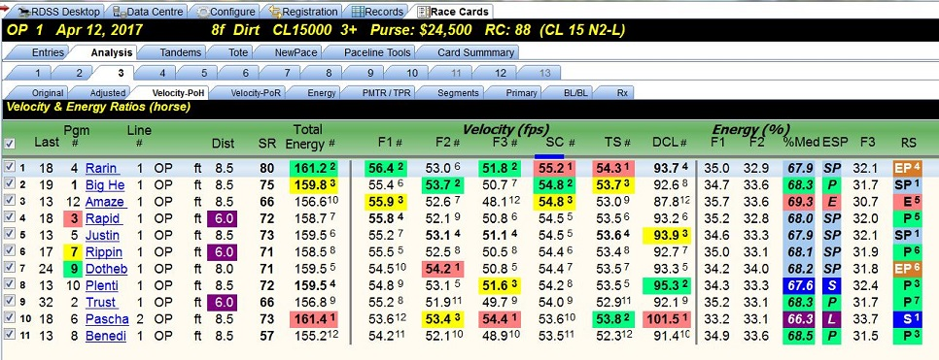

There are 2 ‘Velocity’ screens, ‘PoH’ and ‘PoR’. PoH means ‘Pace of the Horse’ and PoR, the following screen, means ‘Pace of the Race’. Each screen displays the horse’s velocity and energy ratios from the selected paceline. PoR shows the velocity of the front-runner in each race segment (F1, F2, and F3), while PoH is PoR plus/minus lengths gained/lost by the horse during each segment. Thus, a gate-to-wire winner will have the same PoH and PoR numbers: the horse WAS the Pace of the Race.
The number sign (#) in some of the column headers throughout the software denotes a ranking column for the adjacent rating. Additional information on the PoH screen includes the following:
SR – RDSS Adjusted Speed Rating (not the Trackmaster SR), described in the previous screen.
Total Energy – Total Energy (TE), refers to the Total Energy of the horse and is the sum of the 3 fractional velocities of the horse itself, i.e. F1 + F2 + F3 = Total Energy. http://paceandcap.com/forums/archive/index.php?t-8912.html

Velocity (fps) – this section contains the horse’s velocity, measured in feet per second, for the following:
- F1 - First fraction of the race, two furlongs in a sprint, four furlongs in a route.
- F2 - Second fraction, the middle two furlongs of the race.
- F3 - Third fraction, the final segment of the race, which varies depending on the distance.
- SC - Second call or Early Pace, i.e. second call distance / second call time.
- TS - True or Total Speed, velocity for the race, i.e. total distance in feet / final time.
- DCL - Deceleration, third fraction velocity divided by second call velocity, i.e. F3 / SC
http://paceandcap.com/forums/showthread.php?t=8339

Energy % - this section contains four new data elements, all pertaining to Energy:
- F1 – Percentage of Total Energy expended in first fraction, i.e. F1 / Total Energy
- F2 – Percentage of Total Energy expended in second fraction, i.e. F2 / Total Energy
- %Med – Percentage Median, the percentage of Total Energy expended by the Second Call, i.e. (F1 + F2) / (F1 + F2 + F3) or more simply, F1 + F2.
- F3 – Percentage of Total Energy expended in third fraction, i.e. F3 / Total Energy

ESP – A running style classification based on energy and represents where in a race a horse expends the important portion of its energy. See explanation on Analysis/Energy screen.

Analysis/Velocity-PoR Screen

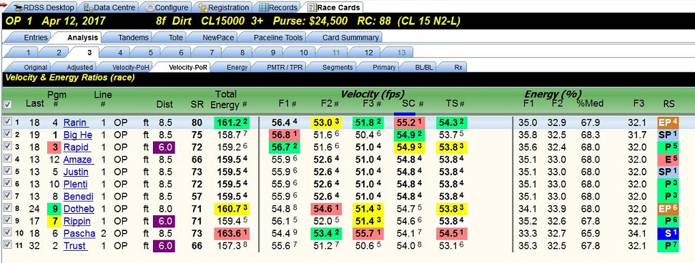

‘PoR’ means ‘Pace of the Race’ and this screen displays the front runner’s velocity and energy ratios in the selected pacelines of the horses in today’s race. As stated previously, a gate-to-wire winner will have the same PoH and PoR numbers: the horse WAS the Pace of the Race.
The data items and formulae on this screen are identical to the ‘PoH’ screen immediately preceding. The only differences will be the Energy and Velocity numbers for horses NOT on the lead.
Again, these are not raw values. They have been adjusted by the DTV and ITV and equalized for today’s distance/surface if different from the selected paceline.

Analysis/Energy Screen

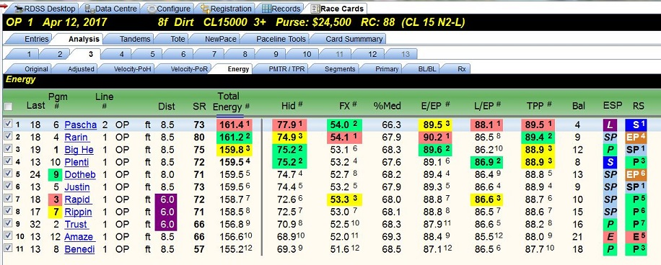

The first nine columns of this screen are the same as the Velocity – PoH screen, although the horses are sorted based on Total Energy #. The following are new data items.
Hid – Hidden Energy, weighted average of the velocities of second and third fractions, i.e. F2 + F3 / 2.
FX – Factor X, the average of the velocities for the first and third fractions, i.e. F1 + F3 / 2.
%Med – Percentage Median, the sum of the velocities for the first and second fractions divided by the sum of the velocities for the first, second and third fractions, i.e. (F1 + F2) / (F1 + F2 + F3).
E/EP – Early Energy Potential, a blending of all three fractional velocities balanced toward the first two fractions. (Considered an improvement on the older EPR as a measurement of early energy distribution.)
L/EP – Late Energy Potential, a blending of all three fractional velocities balanced toward the third fraction. (Considered an improvement on the older LPR as a measurement of late energy distribution.)
TPP – Total Pace Potential, a combination of E/EP and L/EP.
Bal – Balance, the sum of E/EP and L/EP. For dirt races, a balance of energy distribution is desirable and a lower ‘Bal’ number shows a good E/EP and acceptable L/EP. Many “dirt” winners have a low balance, e.g. 4, 5 or 6, while winners in turf races often have a Bal over 8.

ESP – A running style classification based on Energy. It represents a range of %Med values (defined above) and describes where in a race a horse expends the important portion of its energy, i.e. early vs late. (Of course, it matters where the horse needs to have energy to expend, given today’s match up, track, distance, surface, etc.) The TPR + E/L screen provides the same information in bar graph form, although calculated by a different formula and without making use of Fraction 1 velocities/energy %, i.e. 2nd call time based only). http://paceandcap.com/forums/showthread.php?t=3376

RS – The traditional ‘visual’ running style classifications with Quirin Speed Points.

Analysis/PMTR/TPR Screen

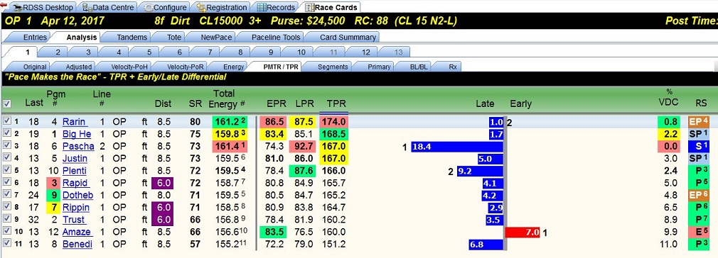

This screen displays Total Pace Ratings, its two components, and the Early/Late Differential in ‘graph’ form (commonly called the ‘sticks’).
After the “Dist” column, the following are displayed.
SR – RDSS Adjusted Speed Rating for the selected paceline.
Total Energy – Total Energy (TE), refers to the Total Energy of the horse and is the sum of the 3 fractional velocities of the horse itself, i.e. F1 + F2 +F3 = Total Energy.
EPR – Early Pace Rating, a rating based on the horse’s velocity to the Second Call.
LPR – Late Pace Rating, a rating based on the average of the horse’s Second Call and Third Fraction velocities, i.e. SC + F3 / 2.
TPR – Total Pace Rating, the sum of EPR and LPR.
Late Early bar graph – A visual representation of where the horse uses its Energy, either Late or Early. It is the difference in points of the LPR number subtracted from the EPR number. A positive difference indicates a surplus of Early energy, while a negative difference indicates a surplus of Late energy, as measured in the PMTR points system.
VDC% – Velocity relative to Deceleration, is a fraction by fraction summing of deceleration relative to how fast the horse was running in that fraction, expressed in a ‘Perceptor’ format, i.e. percentage deviation from the ‘best,’ the best represented as ‘0.0’. (Perceptor is described in more detail on the ‘Primary’ screen following.) The purpose of VDC is to show how well a horse did at overcoming the pace of the race, even if ranked lower on BL/BL, which it often would be if it happened to have lower Total Energy.

RS – The traditional ‘visual’ running style classifications with Quirin Speed Points.

Analysis/Segments Screen

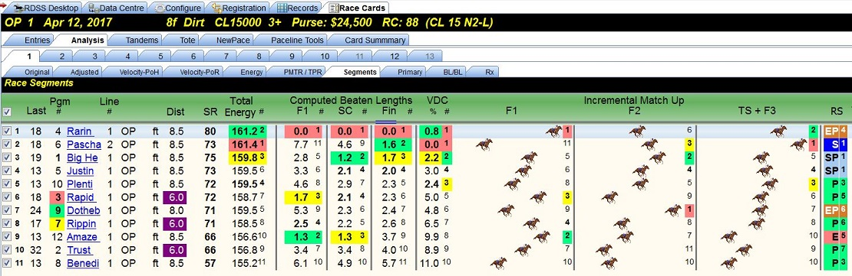

In addition to information previously shown and described, this screen displays the following:
Computed Beaten Lengths:
- F1 – determined by the horse’s velocity for Fraction 1.
- SC – determined by the horse’s velocity to the Second Call, i.e. Fractions 1 and 2.
- Fin – determined by the horse’s average velocity for the entire race, i.e. total distance / final time. (Average velocity for the entire race is also True Speed (TS) and is consistent with the RDSS Adjusted Speed Rating (ASR) in rankings.)

VDC% – Velocity relative to Deceleration, is a fraction by fraction summing of deceleration relative to how fast the horse was running in that fraction, expressed in a ‘Perceptor’ format, i.e. percentage deviation from the ‘best,’ the best represented as ‘0.0’.
Incremental Match Up – A visual representation of how the horses match up on velocity within each race segment, using the selected pacelines.
- F1 – determined by the horse’s F1 velocity.
- F2 – determined by the horse’s F2 velocity
- TS + F3 – determined by averaging the horse’s True Speed + F3 velocity.

Each segment is portrayed individually, as if there were three different races. They are not cumulative. For the projected winner, see Computed Beaten Lengths – Fin column.

Analysis/Primary Screen

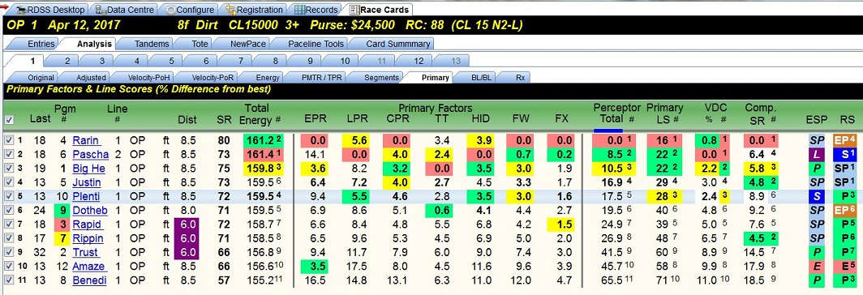

This screen displays the rankings of the seven ‘Primary Factors’ that comprise the Line Score (thus the tab name ‘Primary’), the Perceptor Total, the Primary Line Score, the Velocity/Deceleration percentage and the Composite Speed Rating, all presented in the “Perceptor” format except the Primary LS.
Perceptor is a concept carried forward from earlier Sartin program Speculator and shows factors in terms of their percentage deviation from the best, which is represented as ‘0.0’. It helps reveal how close different numbers are. For example, a difference of 0.1% (1/10th of one percent) is insignificant and indistinguishable from chart-caller error, while a difference of 24.2% is very significant.
Primary Factors (shown in ‘Perceptor’ style percentages)
- EPR – Early Pace Rating, a rating based on the horse’s velocity to the Second Call.
- LPR – Late Pace Rating, a rating based on the average of the horse’s Second Call and Third Fraction velocities.
- CPR – Composite (or Total) Pace Rating, a rating based on the sum of EPR and LPR.
- TT – Turn Time, a rating based on the horse’s velocity for the Second Fraction.
- HID – Hidden Energy, a rating based on the “weighted” average of the velocities of the Second and Third Fractions.
- FW – Factor W, a rating based on the average of all three fractions. For sprints, it’s (SC x 2) + F3 / 2. For routes, it’s SC + (F3 x 2) / 2.
- FX – Factor X, a rating based on the average of the velocities for the First and Third fractions, i.e. F1 + F3 / 2.

Perceptor Total – The percentage deviation from the best Line Score, which is represented as ‘0.0’.
Primary LS – The sum of the Perceptor percentage differences of the 7 Primary Factors, with their varying weights.
VDC% - Velocity relative to Deceleration (described on ‘Segments’ screen above) expressed in Perceptor format.
Comp SR – Composite Speed Rating, based on Adjusted SR only and not on the TrackMaster SR, expressed in Perceptor format. It is a weighted composite of the last 4 valid Adjusted SRs and can be modified by Configuration Settings. Also displayed on the ‘Entries’ screen.

Analysis/BL/BL Screen

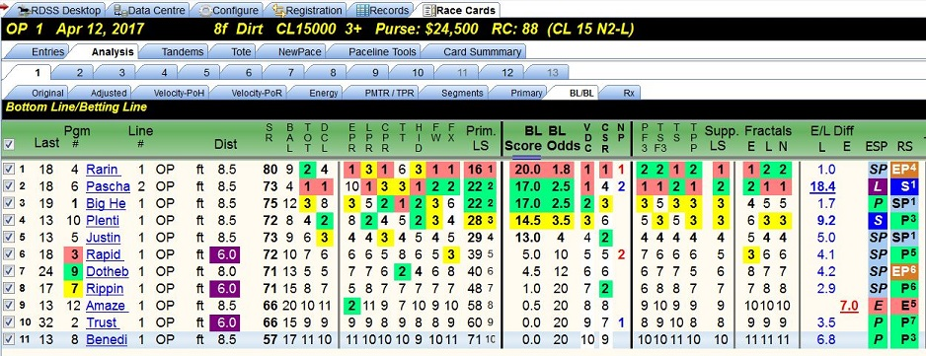

“BL/BL is the central, summary screen. All the other screens are feeder screens, or fancy ways of impactfully portraying the ratings as they progress from Raw to Adjusted to Compounded.” http://paceandcap.com/forums/showthread.php?t=5879
Most of the categories of data have appeared and been described on prior ‘Analysis’ screens. On the ‘Bottom Line Score, Betting Line Odds’ screen, abbreviated ‘BL/BL’, that data is brought together with most presented as rankings for the horse’s selected paceline.
SR – Speed Rating, the RDSS Adjusted Speed Rating (described on the ‘Adjusted’ screen).
BAL – Balance, the sum of E/EP and L/EP (described on the ‘Energy’ screen).
TOT – Total Energy, the ranking of the horse’s Total Energy, which is the sum of the 3 fractional velocities (described on the ‘Energy’ screen).
DCL – Deceleration, the ranking of the horse’s Deceleration, which is the Third Fraction velocity divided by the Second Call Velocity, i.e. F3 / SC.
The next seven columns are rankings for the Primary Factors or ‘Corollaries’ of the Primary Line Score.
EPR – Early Pace Rating, a ranking based on the horse’s velocity to the Second Call.

LPR – Late Pace Rating, a ranking based on the average of the horse’s Second Call and Third Fraction velocities.

CPR – Composite (or Total) Pace Rating, a ranking based on the sum of EPR and LPR.

TT – Turn Time, a ranking based on the horse’s velocity for the Second Fraction.

HID – Hidden Energy, a ranking based on the “weighted” average of the velocities of the Second and Third Fractions.

FW – Factor W, a ranking based on the average of all three fractions. For sprints, it’s (SC x 2) + F3 / 2. For routes, it’s SC + (F3 x 2) / 2.

FX – Factor X, a ranking based on the average of the velocities for the First and Third fractions, i.e. F1 + F3 / 2.

Prim. LS – Primary Line Score is the total of the rankings for the seven Primary Factors.

BL Score – Bottom Line Score is the line score that is computed from the seven Primary factors with their specific weightings.

BL Odds – Betting Line Odds is the odds line generated by RDSS from the Line Score. Its purpose is to show betting value when the RDSS odds are compared to ‘tote’ odds.

VDC – Velocity relative to Deceleration, a ranking based on a fraction by fraction summing of deceleration relative to how fast the horse was running in that fraction (described on the ‘Segments’ screen).
CSR – Composite Speed Rating, a ranking based on the weighting of the RDSS Adjusted Speed Rating from the last 4 usable lines, regardless of distance, surface, race conditions or finish (described on the ‘Entries’ and ‘Primary’ screens).
NP - Early/Late Plus indicates the top two Early and top two Late horses.
The next four columns are rankings for the Supplementary Factors or ‘Corollaries’.
PF3 – Projected Fraction 3, a ranking of the Third Fraction time with beaten lengths added. (Also known as the ‘Projected Power Fraction’ described by Mike Pizzolla and others.)
TS F3 – True Speed plus F3, a ranking of the average of True Speed + Third Fraction velocity, i.e. final time with extra weight for the last fraction.
TS – True Speed, a ranking of average velocity for the entire race, identical to Adjusted Speed Rating.
TPP – Total Pace Potential, a ranking of the aggregate of E/EP (Early Energy Potential) and L/EP (Late Energy Potential. Considered an improvement by Sartin over the earlier EPR + LPR = CPR.
Supp. LS – Supplementary Line Score, a ranking of the Supplementary Corollary totals (which are not shown).
Fractals – a ranking of a collection of energy disbursement blends, Early, Late and Normal (Unbiased), depending on which energy disbursement style the user judges the contenders to run as. For example, if there are 3 “Earlies” with fairly equal early energy ability, consider the higher ranked Late Fractal readout because the Earlies may wear each other out. Per Ted - “Doc thinks that in general Fractals was an inconclusive concept, yet left them in anyway because of demand. RDSS provides them for backward compatibility with Val and Spec.” http://paceandcap.com/forums/showthread.php?t=4115

Analysis/Rx Screen

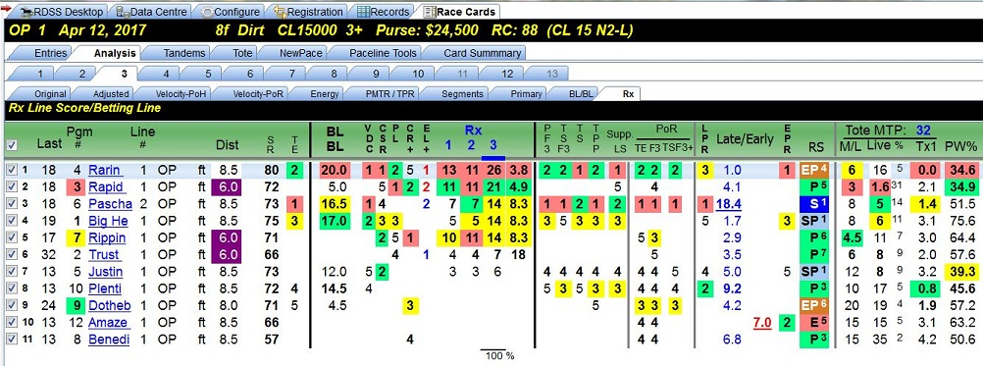

Rx is a newer Analysis Screen in RDSS 2.1. Each Rx factor is a line score and odds line composed of other line scores and composite factors, some non-correlated to Pace/Speed/Energy to give a comprehensive view of the true contenders. It is an alternative to BL/BL. Like BL/BL it comprises a weighting of other factors, in this case: VDC, CSR, an optional outside factor such as ProfitLine, CR+, and a composite Early/Late measurement.

All information on this screen has been displayed and explained previously on other screens but will be displayed again here for clarity and ease of reference.

Last – Days since last race and in superscript, days since last work. The same information appears on the ‘Entries’ screen as ‘Last Race/Wk.’
Pgm # – Horse’s program or saddle-cloth number, followed by horse’s name.
Line # – The paceline (or running line or race) selected for evaluation, followed by the track abbreviation where the race was run and condition of the track surface.

Dist – The distance of the race.

SR – RDSS Adjusted Speed Rating.
TE - Total Energy, a ranking of the sum of the 3 fractional velocities of the horse.

BL/BL – Bottom Line, Betting Line score from the Analysis/BL/BL screen.

VDC – Velocity relative to Deceleration, a ranking of the fraction by fraction summing of deceleration relative to how fast the horse was running in that fraction.

CSR – Composite Speed Rating, a ranking of the weighting of the Adjusted Speed Rating from the last 4 usable lines, regardless of distance, surface, race conditions or finish. Highly predictive factor as more than 80% winners come from the top 5.

PL - The ProfitLine ranking from TwinSpires.
www.twinspires.com/news/2007/9/18/profitline-horse-racing-odds-twinspires

CR+ - Class Rating Plus, a ranking of the enhanced measure of class (uses the old CR with a weighted ranking of the horse’s final odds from its last four races).

E/L+ - Early/Late Plus, indicates the top two Early (red) and top two Late (blue) horses, using a refined pace method.

Rx – As described above, Rx is a composite line score factor comprised of weighted input from VDC, CSR, CR+, EL+, and an additional component, as follows:
- Rx1 – uses Morning Line rank
- Rx2 – uses additional weighting for CR+
- Rx3 – uses ProfitLine
http://paceandcap.com/forums/showthread.php?t=10574

The next four columns are rankings for the Supplementary Factors or “Corollaries”.
PF3 – Projected Fraction 3, a ranking of the Third Fraction time with Second Call beaten lengths added.
TS F3 – True Speed plus F3, a ranking of the average of True Speed + Third Fraction velocity, i.e. final time with extra weight for the last fraction.
TS – True Speed, a ranking of average velocity for the entire race, identical to Adjusted Speed Rating.
TPP – Total Pace Potential, a ranking of the aggregate of E/EP (Early Energy Potential) and L/EP (Late Energy Potential.
Supp. LS – Supplementary Line Score, a ranking of the four Supplementary Factors.
PoR – rankings of three “Pace of Race” factors from the horse’s selected paceline:
- TE – Total Energy of the race winner.
- F3 – Third Fraction velocity of the race winner.
- TSF3+ - True Speed plus F3, a ranking of the average of True Speed + Third Fraction velocity, i.e. final time with extra weight for the last fraction, for the race winner.

Late/Early – rankings of the Late Pace and Early Pace Ratings with the E/L Differential, which indicates where in the race the horse uses its energy. If red, it indicates the horse uses more energy by the Second Call. If blue, the horse uses more energy in the Third Fraction.

RS - the horse’s “Running Style” and in superscript, the horse’s Quirin Speed Points.

Tote
- MTP – Minutes to Post
- M/L – Morning Line Odds on the horse.
- Live – Live tote odds on the horse.
- % – Horse’s odds of winning expressed as a percentage.
- Tx1 – original Tote Xray, measures relationships between the WPS pools.
- PW% - the ratio of Place pool money bet on the horse to Win pool money bet on the horse.

Mutuel Prices – provides post race WPS, Exacta and Trifecta prices, which can be exported with other data to Excel.

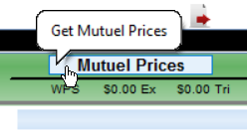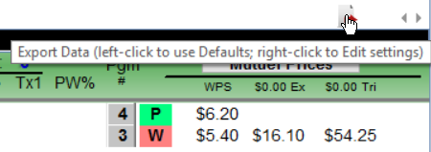

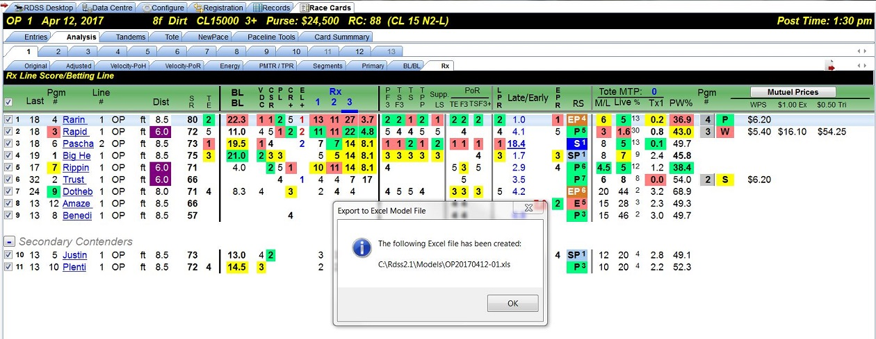

Here's a video by RichieP showing how to use the “Export to Excel” feature to send Analysis data to an Excel file so it can be used in Factor Models.

http://www.sartinmethodology.com/media/Rdss2ExcelModels.wmv

Results, when available, can be obtained by clicking the “Result Chart” button on the “Entries” screen.

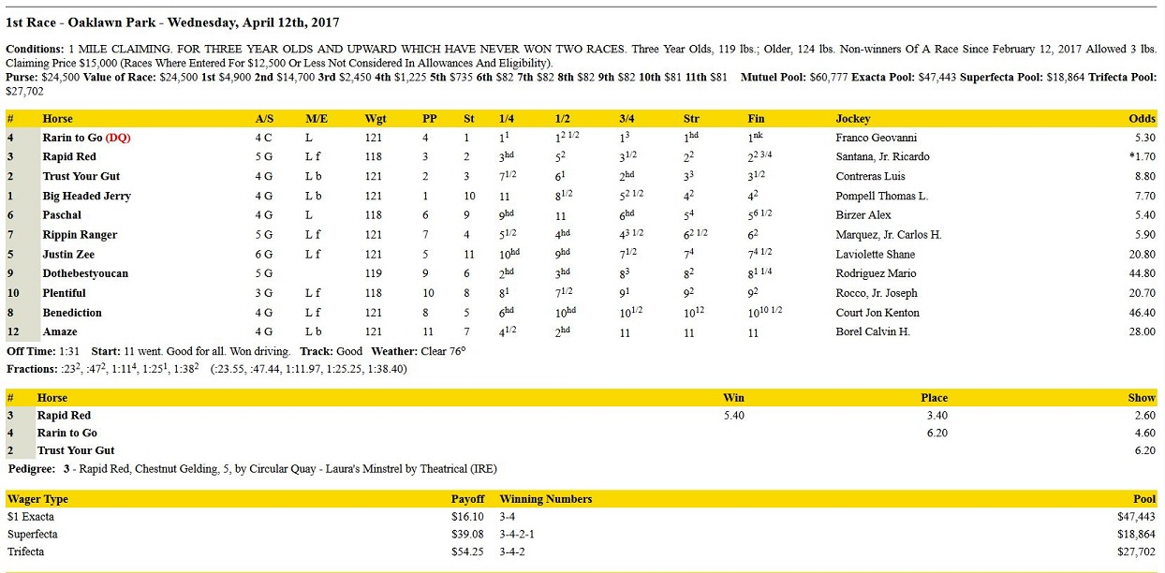

Single Entry Screens

Analysis/Original

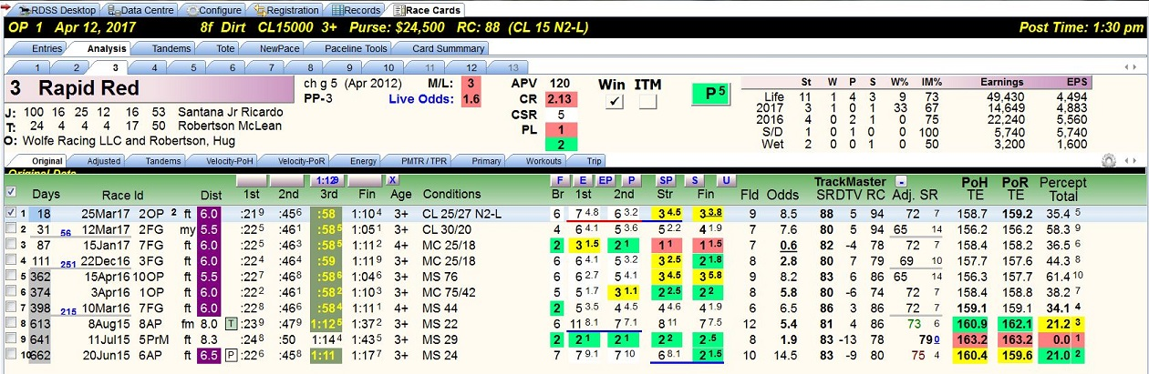

The single entry screens provide information about one horse, as opposed to the “field” screens that provide information for all horses in the race.

The upper section of the single entry screens are identical while the content of the lower section varies with the information being presented.

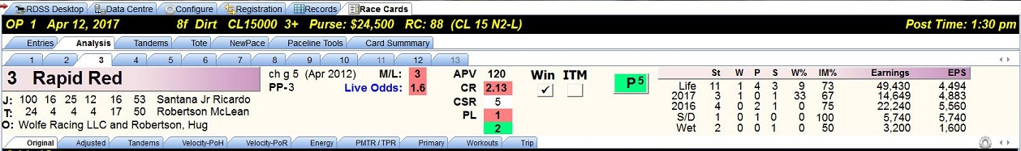

Left portion:
- Program or saddle-cloth number;
- Horse’s name;
- Horse’s color, sex, age and month and year of birth;
- Post position;
- Jockey’s name preceded by the jockey’s record for the past thirty days in the following order – Starts, Wins, Places, Shows, Win percentage, In the Money percentage;
- Trainer’s name preceded by the trainer’s record for the past thirty days in the following order - Starts, Wins, Places, Shows, Win percentage, In the Money percentage; and
- Owner’s name.

Center portion:
- Horse’s Morning Line odds;
- Horse’s Live Odds (if SuperTote enabled);
- Horse’s Average Purse Value, Class Rating, Composite Speed Rating ranking, and ProfitLine ranking (all described on the “Entries” screen);
- Win and ITM check boxes (described on the following page); and
- Horse’s Running Style with Quirin Speed Points.
Right portion:
- Horse’s basic racing statistics for:
  - its lifetime;
  - current year;
  - previous year;
  - on the same surface and at the same distance of today’s race (S/D); and
  - on a wet track.
- For each of the above, the statistics include:
  - number of Starts;
  - number of first (W), second (P) and third place (S) finishes;
  - horse’s win percentage (W%);
  - horse’s in the money percentage (IM%);
  - horse’s earnings; and
  - horse’s average earnings per start (EPS).

The “Win” and “ITM” check boxes enable the user to “group” horses into Primary Contenders, Secondary Contenders and Non-Contenders.

If a horse’s “Win” box is checked, the horse is shown as a Primary Contender on all Field Analysis screens.

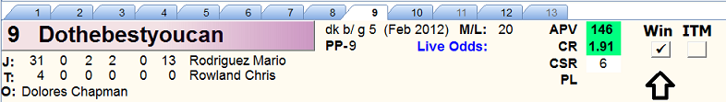

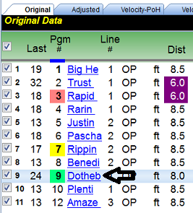

If a horse’s “ITM” box is checked, the horse is shown as a Secondary Contender. (A horse can be “toggled” between Primary and Secondary Contender by right-clicking on the checkbox to the left.)

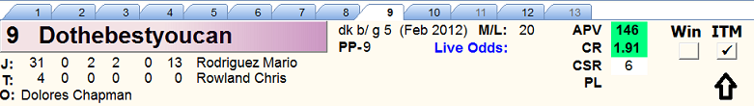

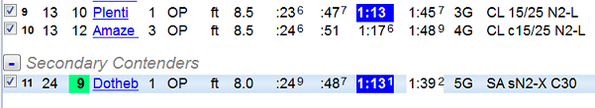

If neither box is checked, the horse is shown as a Non-Contender.

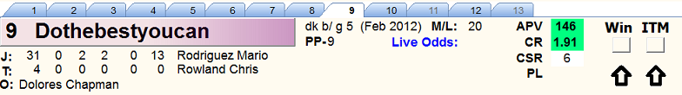

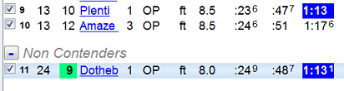

The Win and ITM checkboxes can be used for other purposes too, such as grouping horses by Running Style for comparison or “matching.”

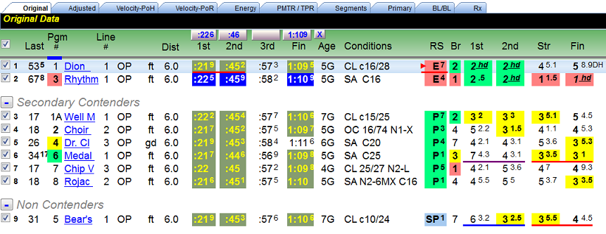
The lower section of the “Original” screen displays traditional Equibase past performance information for the horse’s last ten races (or all races if less than ten). For each race, there is a selected paceline checkbox, TrackMaster supplied data, the Adjusted Speed Rating, Pace of Horse and Pace of Race Total Energy ratings and the Perceptor Total. The fractional and final times are raw, unadjusted numbers.

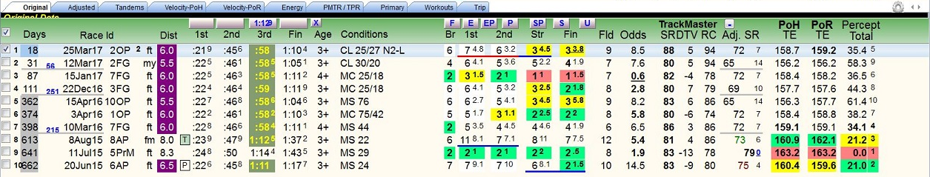

Projected Pace and Running Style buttons – Located across the top of the lower section are two sets of buttons. The first allows the user to set the projected pace of the race. The second allows the user to change the horse’s designated Running Style.

Right-click on the time to set the Projected Pace for that race segment.

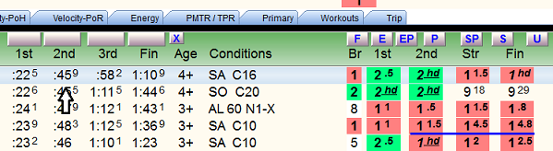

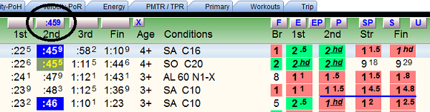

You can adjust the projected pace with a mouse click.

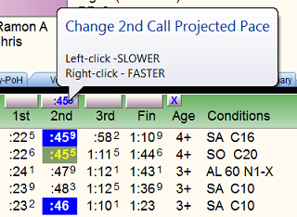

Projected times can be set and adjusted for all segments. Note highlighting for previous races which helps identify comparable or faster times. Projected times can be cleared by clicking the “X” button.

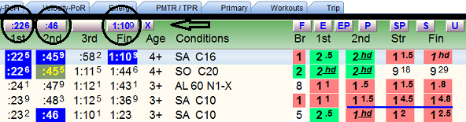

To change a horse’s Running Style, click the appropriate Running Style button.

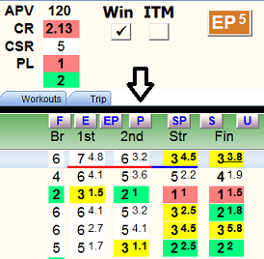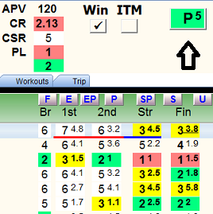

Paceline checkbox – Located to the left of each race, this column of checkboxes allows the user to manually select the race that will be analyzed and displayed on the field analysis screens. Multiple pacelines can be selected by holding down the Ctrl key and checking more than one box. All pacelines can be selected using the checkbox at the top of the column.

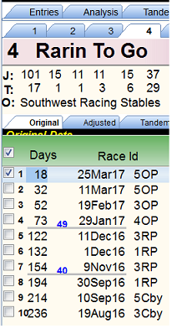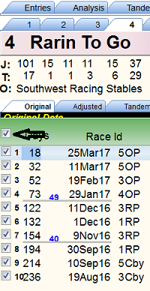

Automatic paceline selection is controlled with the Paceline Tools screen, which provides multiple options (including “00 Manual” that deselects all races).

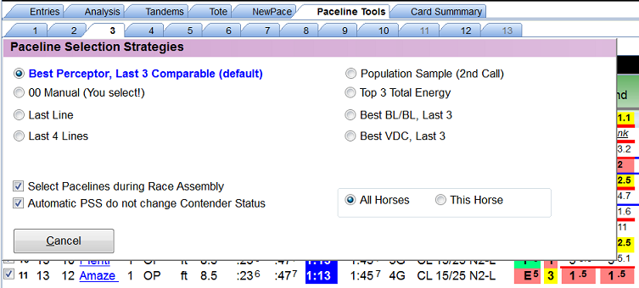

Days – Number of days since last race and the interval or number of days since previous race.
The following nineteen columns present traditional past performance information for the horse’s most recent races, up to a maximum of ten.
TrackMaster Supplied Ratings
- SR – TrackMaster’s Speed Rating, from which Inter-Track Variants are extracted, used to adjust the running times in all Sartin download programs. It’s the horse’s final time adjusted by:
a) Daily Track Variant (how fast/slow that day's surface was);
b) Inter Track variant (how fast or slow each surface is relative to a universal norm); and
c) horse's speed rating (compared to the 'par' for that track/distance/surface).
- DTV – Daily Track Variant of the selected paceline race. (RDSS has a feature available on the ‘Config’ screen to ‘smooth out the extremes’ for very slow and very fast races, e.g. + - 15, so that the final times aren’t adjusted unreasonably.)
- RC – Race Class, a composite of the most recent final time Speed Ratings of all the horses in the selected paceline race. (It’s included for reasons of historical continuity as it was in some Sartin programs, but Dr. Sartin did not use it and Ted recommends that it be ignored except that is useful for rating Foreign Shippers, as this TimeForm International Rating can be used to compare foreign races’ relative Class Levels with all other horses, typically at the Breeders’ Cup!)
Adj SR – Adjusted Speed Rating, computed by RDSS using internal formulas and includes:

- Final time component;
- Distance adjustment to today's distance (if necessary);
- TrackMaster's Daily Track Variant (DTV) adjustment (controlled on the Config screen); and
- TrackMaster's Inter-Track Variant (ITV) adjustment.

Note: The Adjusted SR is not the same as the TrackMaster SR and does not include adjustments for:

- 'class' as determined by earnings or in-the-money consistency (i.e. elements of APV and CR);
- race conditions or caliber of race (race class levels, non-winner conditions, etc);
- 'track class' or relative level of purse structures or perceived abilities of horses who race at different race tracks or circuits; or
- incremental race segment components (e.g. 'pace' time ratings, fractional ratings).

It is strictly based on adjusted final time, and as such will have a direct one-to-one rank relationship with Total or ‘True’ Speed (TS) which is the velocity equivalent of the Adjusted Speed Rating (i.e. the rankings of these two readouts would be identical). http://paceandcap.com/forums/archive/index.php?t-8004.html

PoH TE – Pace of Horse Total Energy, refers to the Total Energy of the horse and is the sum of the 3 fractional velocities, i.e. F1 + F2 + F3 = Total Energy.

PoR TE – Pace of Race Total Energy, refers to the Total Energy of the race’s frontrunner and is the sum of the 3 fractional velocities of the frontrunner, i.e. F1 + F2 + F3 = Total Energy.

Percept Total – Perceptor Total, derived from the 7 Primary Factors that comprise the Line Score (see Primary screen below) and indicates the percentage deviation for each race from the horse’s best race, expressed as “0.0”.

Additional functionality

If you hover the mouse pointer over the Fin (Final) column of a race, Trip notes will appear in a popup.

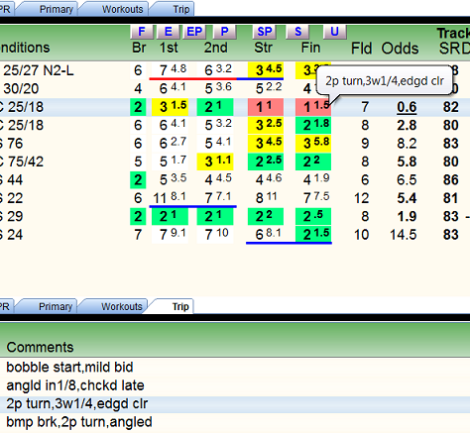

Also in the Final column, if the Beaten Lengths are underlined, it means there was some trouble in the running line.

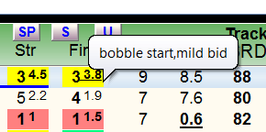

You can see at a glance if a paceline is possibly excusable because of the trouble. If the line was still “good,” perhaps it deserves extra consideration.

The “Configure PP Panel” icon is located on the right-hand side of all Single Entry screens.

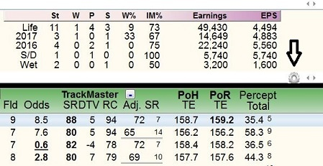

It allows the user to change the “Tab” and “Panel” layouts.
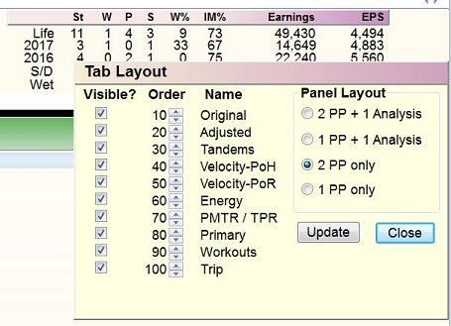

Tandems
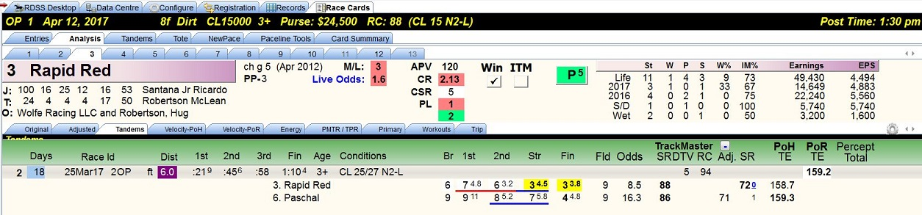

This screen displays prior races where the horse has competed against another horse or horses entered in today’s race. Tandems are an element of Jim Bradshaw’s “Match Up” approach. All data is assembled from other screens, primarily the Analysis/Original with one column each from the Analysis/Velocity–PoH and Analysis/Velocity-PoR, and will be described on those screens.

The “Adjusted” data can be toggled on or off.

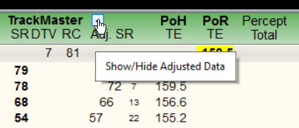

Analysis/Adjusted

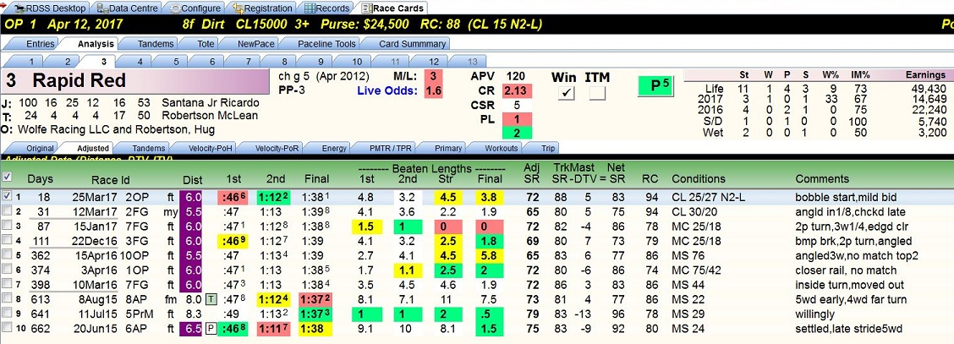

This screen displays the horse’s last races, up to a maximum of ten, with the fractional and final times adjusted by the TrackMaster supplied DTV and ITV. If today’s race is a different distance and/or surface, those fractional and final times are also adjusted or “equalized” to make them consistent with today’s distance and surface.
Note - With the tabbed screens to the right of the ‘Original’ screen, all factors and numbers are adjusted and equalized. The only raw data is on the Original, Tandems, Workouts and Trip information. Otherwise, nothing is raw unless the user has changed the default settings on the ‘Configure’ screen (not recommended).
Also displayed on this screen is an ‘Adj SR’ and a TrackMaster ‘Net SR’ with calculation.
Adj SR – Adjusted Speed Rating, computed by RDSS using internal formulas and includes:
1. Final time component;
2. Distance adjustment to today's distance (if necessary);
3. TrackMaster's Daily Track Variant (DTV) adjustment (controlled on the Config screen); and
4. TrackMaster's Inter-Track Variant (ITV) adjustment

TrackMaster Net SR – “In Validator and Speculator, the TM SR shown is the Net SR, i.e. original TM SR minus DTV. Erring on the side of completeness, I show it all.” Quote from Ted.
http://paceandcap.com/forums/archive/index.php?t-2639.html

Note: TrackMaster data displayed on RDSS screens is for reference/informational purposes only and not for use in handicappin g. Exception: Foreign Horses can be rated on their RC Class levels and TrackMaster SR (TimeForm International SR) relative to the same figures for the rest of the field (useful for Breeders’ Cup races).

Analysis/Velocity-PoH

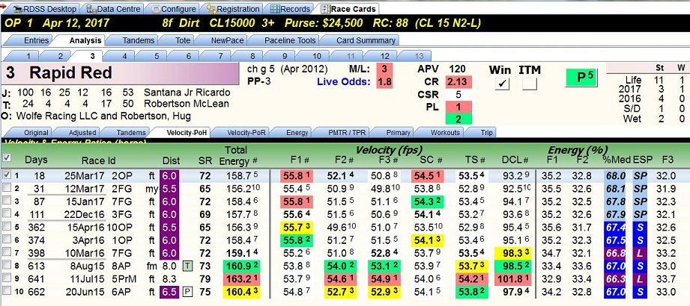

PoH means “Pace of the Horse” and this screen displays the horse’s velocity and energy ratios from its last races, up to a maximum of ten.
The number sign (#) in some of the column headers throughout the software denotes a ranking column for the adjacent rating. Additional information on the PoH screen includes the following:
SR – RDSS Adjusted Speed Rating described in the previous screen.
Total Energy – Total Energy (TE), refers to the Total Energy of the horse and is the sum of the 3 fractional velocities of the horse itself, i.e. F1 + F2 + F3 = Total Energy.

Velocity (fps) – this section contains the horse’s velocity, measured in feet per second, for the following:
- F1 - First fraction of the race, two furlongs in a sprint, four furlongs in a route.
- F2 - Second fraction, the middle two furlongs of the race.
- F3 - Third fraction, the final segment of the race, which varies depending on the distance.
- SC - Second call or Early Pace, the average of F1 and F2.
- TS - True or Total Speed, velocity for the race, i.e. total distance in feet / final time.
- DCL - Deceleration, third fraction velocity divided by second call velocity, i.e. F3 / SC

Energy % - this section contains five data elements all pertaining to Energy:
- F1 – Percentage of Total Energy expended in first fraction, i.e. F1 / Total Energy
- F2 – Percentage of Total Energy expended in second fraction, i.e. F2 / Total Energy
- %Med – Percentage Median, the percentage of Total Energy expended by the Second Call, i.e. (F1 + F2) / (F1 + F2 + F3) or more simply, F1 + F2.
- ESP - Running style classification based on energy and represents where in a race a horse expends the important portion of its energy.
- F3 – Percentage of Total Energy expended in third fraction, i.e. F3 / Total Energy

Analysis/Velocity-PoR

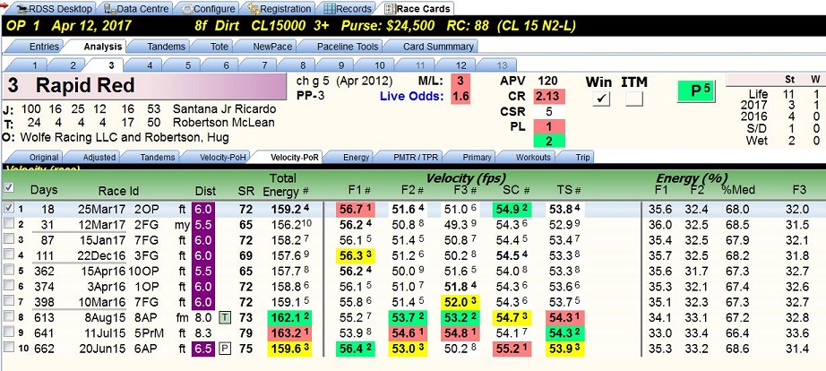

‘PoR’ means ‘Pace of the Race’ and this screen displays the front runner’s velocity and energy ratios in the horse’s last races, up to a maximum of ten.
The data items and formulae on this screen are identical to the ‘PoH’ screen immediately preceding. The only differences will be the Energy and Velocity numbers for horses NOT on the lead.
(Again, these are not raw values. They have been adjusted by the DTV and ITV and equalized for today’s distance/surface if different from the selected paceline.)

Analysis/Energy

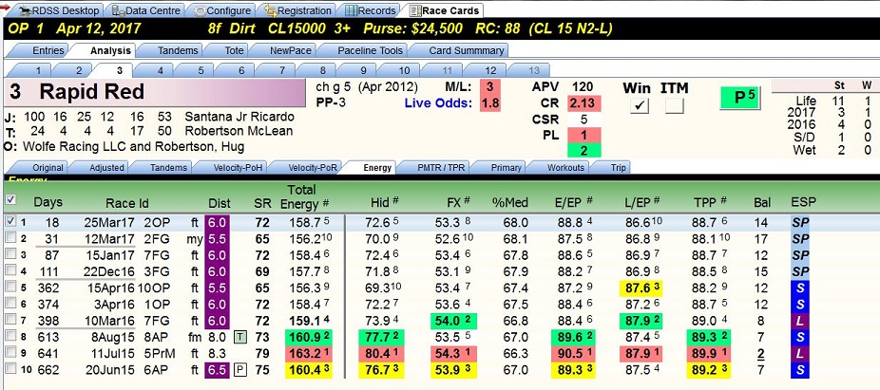

The first nine columns of this screen are identical to the Velocity – PoH screen. The following are new data items.
Hid – Hidden Energy, weighted average of the velocities of second and third fractions, i.e. F2 + F3 / 2.
FX – Factor X, the average of the velocities for the first and third fractions, i.e. F1 + F3 / 2.
%Med – Percentage Median, the sum of the velocities for the first and second fractions divided by the sum of the velocities for the first, second and third fractions, i.e. (F1 + F2) / (F1 + F2 + F3).
E/EP – Early Energy Potential, a blending of all three fractional velocities balanced toward the first two fractions. (Considered an improvement on the older EPR as a measurement of early energy distribution.)
L/EP – Late Energy Potential, a blending of all three fractional velocities balanced toward the third fraction. (Considered an improvement on the older LPR as a measurement of late energy distribution.)
TPP – Total Pace Potential, a combination of E/EP and L/EP.
Bal – Balance, the sum of E/EP and L/EP.

ESP – A running style classification based on Energy. It represents a range of %Med values (defined above) and describes where in a race a horse expends the important portion of its energy, i.e. early vs late.

Analysis/PMTR/TPR

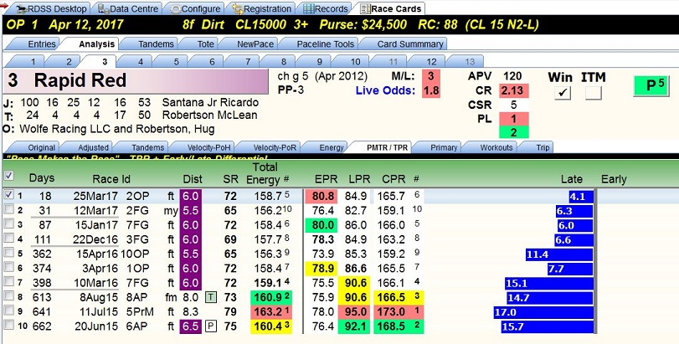

This screen displays Total Pace Ratings, its two components, and the Early/Late Differential in ‘graph’ form (commonly called the ‘sticks’).
After the “Dist” column, the following are displayed.
SR – RDSS Adjusted Speed Rating for the selected paceline.
Total Energy – Total Energy (TE), refers to the Total Energy of the horse and is the sum of the 3 fractional velocities of the horse itself, i.e. F1 + F2 +F3 = Total Energy. (Sartin used Total Energy as a primary elimination factor, reducing the contenders to the top 5 plus ties.)
EPR – Early Pace Rating, a rating based on the horse’s velocity to the Second Call.
LPR – Late Pace Rating, a rating based on the average of the horse’s Second Call and Third Fraction velocities, i.e. SC + F3 / 2.
CPR – Composite (or Total) Pace Rating, the sum of EPR and LPR.
Late Early bar graph – A visual representation of %Med values, i.e. where in a race the horse used its Energy, Early or Late. If Early, represented by a red bar, the horse used more energy by the Second Call. If Late, represented by a blue bar, the horses used more energy in the Third Fraction.

Analysis/Primary

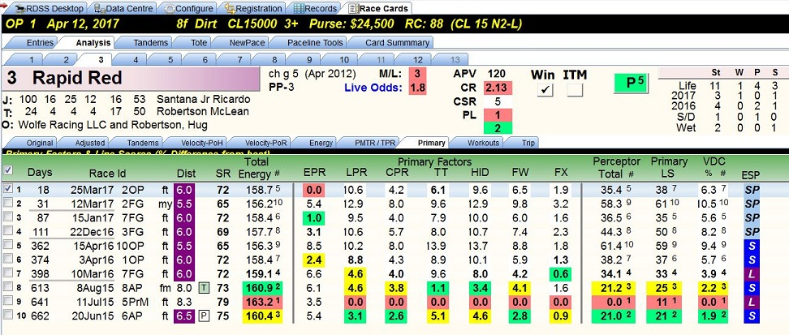

This screen displays the rankings of the seven ‘Primary Factors’ that comprise the Line Score (thus the tab name ‘Primary’), and the Perceptor Total, the Primary Line Score, and the Velocity/Deceleration percentage presented in the “Perceptor” format. As stated on several previous screens, Perceptor is a concept carried forward from the earlier Sartin program Speculator and shows factors in terms of their percentage deviation from the best, which is represented as ‘0.0’.
Primary Factors (shown in ‘Perceptor’ style percentages)
- EPR – Early Pace Rating, a rating based on the horse’s velocity to the Second Call.
- LPR – Late Pace Rating, a rating based on the average of the horse’s Second Call and Third Fraction velocities.
- CPR – Composite (or Total) Pace Rating, a rating based on the sum of EPR and LPR.
- TT – Turn Time, a rating based on the horse’s velocity for the Second Fraction.
- HID – Hidden Energy, a rating based on the “weighted” average of the velocities of the Second and Third Fractions.
- FW – Factor W, a rating based on the average of all three fractions. For sprints, it’s (SC x 2) + F3 / 2. For routes, it’s SC + (F3 x 2) / 2.
- FX – Factor X, a rating based on the average of the velocities for the First and Third fractions, i.e. F1 + F3 / 2.

Perceptor Total – The percentage deviation from the best Line Score, which is represented as ‘0.0’.
Primary LS – The sum of the Perceptor percentage differences of the 7 Primary Factors, with their varying weights.
VDC% - Velocity relative to Deceleration expressed in Perceptor format.
ESP – A running style classification based on Energy. It represents a range of %Med values and describes where in a race a horse expends the important portion of its energy, i.e. early vs late.
Analysis/Workouts
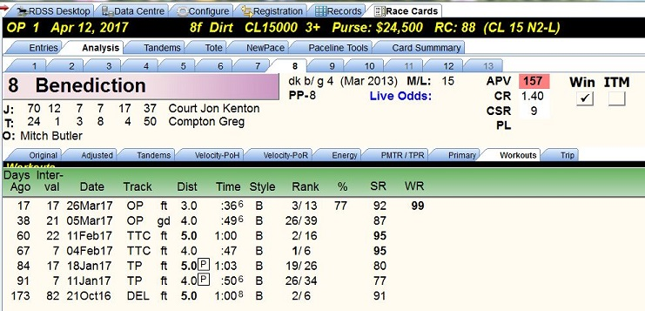

This screen displays details of the horse’s recent workouts as published in Equibase past performances with additional information provided by RDSS.

Days Ago – Number of days since the workout, as calculated from today’s race.

Interval – Number of days since the prior workout.

Date – Date of the workout.

Track – Track on which the workout took place with condition of the surface.

Dist – Distance of the workout.

Time – Time of the workout.

Style – Clocker’s notation of how the workout was run. Examples:
- B – breezing, the horse was not under strong urging
- H – handily, the horse was asked or “handled”
- g – started from the gate
- d – “dogs” or temporary cones were on the track.

Rank – Rank of workout as compared to other works that day of the same distance. A bullet work is in bold type.

% - Percentage of works that were slower. The higher the percentage, the faster the workout by comparison.

SR - Speed Rating, a rating of workout time, based on a parallel time chart equating times for different workout distances. (Speed Ratings of 92+ may indicate the horse is extremely fit and sharp, especially if the workout distance is 5f or longer.)

WR - Work Rank, a computation based on the average percentile of a horse's workout rank for all workouts in a day (when at least 5 workouts recorded that day), plus furlongs worked and raced - over the past 30 days. (It’s a measure of the horse’s fitness.)
Workout Form Patterns – Abbreviations to document how the horse has been working, as follows:
- FPD - Furlongs Per Day. When there are 2 or more workouts since the last race, and within the past 30 days: count the furlongs worked including the distance of today's race and divide by days since the last race. 1 furlong per day = FPD, less is -FPD, more is +FPD. We're trying to get a coarse idea of how much public work the horse has been doing to return to racing. You can only put so much value in this info - this does not tell us how much private work the horse has done, the frequency, the speed, the pressure during (e.g. working in company, working inside/outside other horses, etc), the distance, etc. Consult other Workout Patterns for some of these.
- 5f / 6f - 5 or 6 Furlong Workout. The last workout within 9 days of today's race was either 5 or 6 furlongs, an important endurance distance associated with at least a certain degree of fitness, especially if combined with a good Speed Rating and coming at the end of an evenly spaced series of works (see HWL group). If the last work was within 6 days, will be indicated with a plus, e.g. +5f or +6f.
- SRW - a Short Recent Work between 2f - 4f within 3 to 5 days of today's race
- SW - Super Workout. Depending on distance and recency, a designation for the LAST workout within the past 14 days, run faster than a certain time for each distance.
- GW - Gate Workout. Within the past 8 days, a workout from the Gate. Extra credit for more recent gate workouts (* ! + modifiers)
- HWL1 - Heavy Workload 1. 3 or more workouts within the last 21 days. +HWL1 for 4 works in 20 days or 3 works in 16 days. -HWL1 for 3 works in 21 days
- SAR - Heavy Workload 2. Between 4 and 7 workouts since the last race at *regularly* spaced intervals. Extra credit for more workouts.
- SCW - Special Condition Workouts. Comparing workout immediately prior to the last race within 60 days to workout immediately following that last race - the latter workout is faster and may indicate that the last race did not adversely affect the horse. Or, comparing workouts immediately preceding and following the last 2 races with an out of the money finish, the later workout should be faster, perhaps indicating that the previous 2 races also did not adversely affect the horse's condition and it may be ready to offer at least as good an effort today.
- PIW - Progressively Improving Workouts. Comparing the past 3 workouts within 75 days (preferably shorter), each next workout should be run at increasing average speed.
- TCW - Turf Course Work. For a horse's first Turf race, its last workout is on Turf.
http://paceandcap.com/forums/showpost.php?p=97044&postcount=13
http://paceandcap.com/forums/showthread.php?t=10477

Analysis/Trip

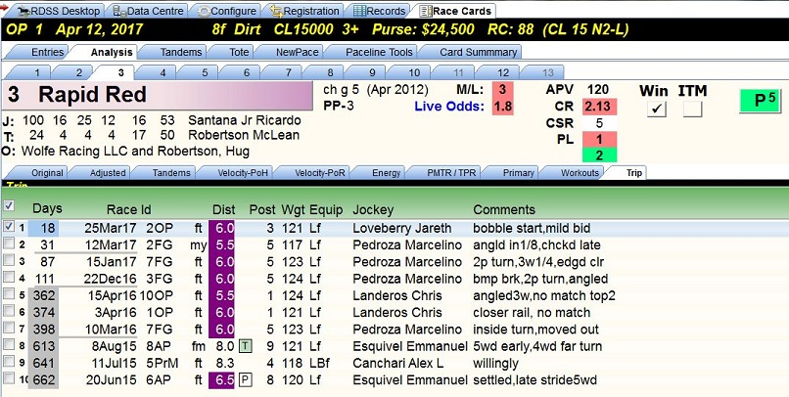
This screen displays details of the horse’s races as published in Equibase past performances. RDSS adds a column that shows how long ago each race was.

Paceline checkbox – Located to the left of each race, this column of checkboxes allows the user to manually select the race that will be analyzed and displayed on the field analysis screens. (Multiple pacelines can be selected by holding down the Ctrl key and checking more than one box.)
Days – Number of days since last race.
Race Id – The date of the race, the track on which it was run and the number of the race on that day’s card.

Dist – The distance, surface and condition of the surface over which the race was run.

Post – The horse’s post position.

Wgt – The weight that the horse carried.

Equip – The horse’s medications and equipment. Examples:
- L – Lasix
- B – Bute
- f – front bandages
- b - blinkers

Jockey – The horse’s jockey for that race.

Comments – Abbreviated chart caller comments from the Equibase results charts.

Configure Screen

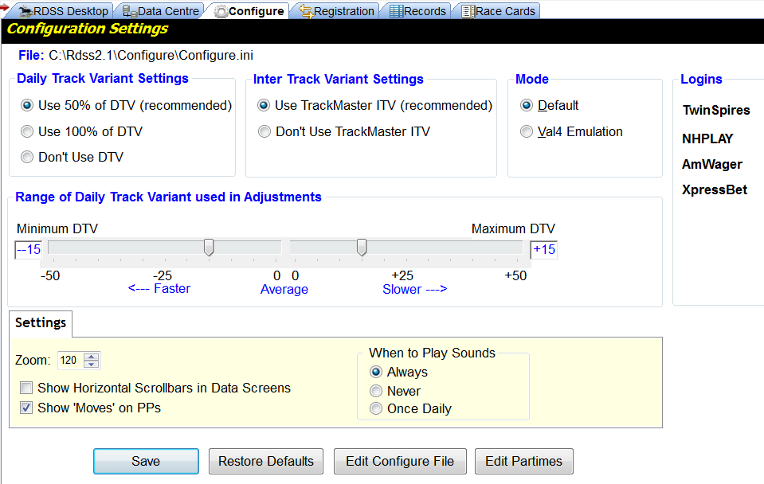

This screen allows the RDSS user to change the Daily Track Variant and Inter Track Variant settings, among other things. (The recommended settings are shown.)

Paceline Tools Screen

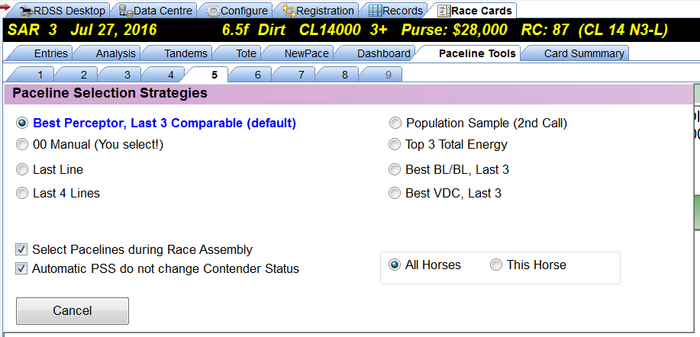

This screen allows the RDSS user to change the paceline used by the field analysis screens. (The recommended setting is shown.)

